Indigenous Peoples of North America
Anthropology 3110
Syllabus
Fall 2018

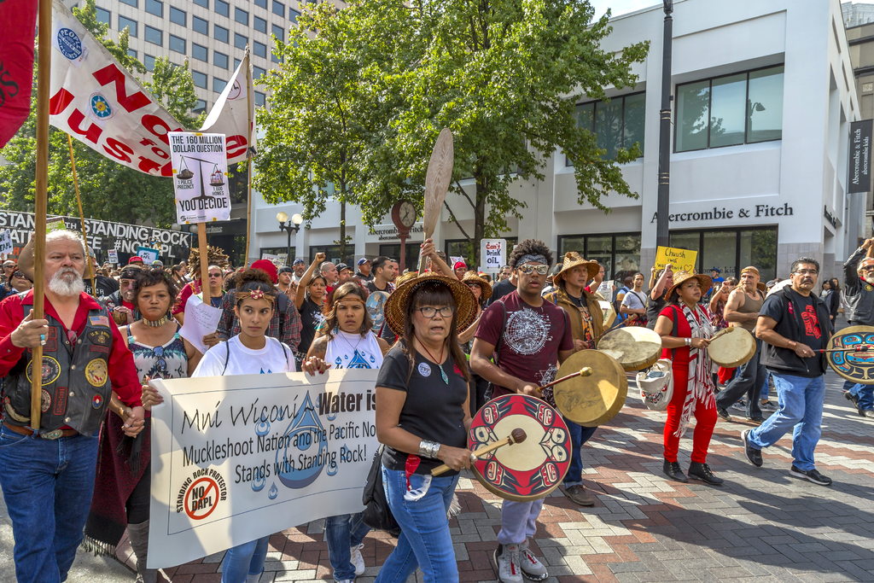
Table of Contents

Contact Info/Office Hours 2
Course Introduction 2 Required Texts 2
Indigenous Voices 2
Learning Objectives 2
Assignments 3
Objectives/Assignments Table 3
Grading Scale 3
Grading Composition 3
Course Policies 4
Strategies for Success 5
A Note on the Syllabus 5

Contact Information/Office Hours

Dr. Adam Dunstan
Email: adam.dunstan@unt.edu
Phone: (940) 565-2170
Office: Chilton Hall 330G
Office Hours: T/Th 1-2 PM and by appt.

Course Introduction

“Native survivance is an active sense of presence over absence,” - Gerald Vizenor
This course explores the cultural diversity, ways of life, history, and present-day realities of the indigenous peoples of North America – those peoples present on this continent prior to the arrival of Europeans. This course is particularly oriented towards overcoming persistent and incorrect stereotypes among non-indigenous Americans about indigenous peoples. Where mainstream media represents Native Americans as a monolithic whole, we will use ethnographic studies and indigenous scholarship to show how there is no homogenous group of “Native Americans”: rather, there are hundreds of indigenous nations in North America, and we will attempt to briefly survey this vast and rich cultural diversity. Furthermore, while indigenous peoples and colonial assaults against them are often thought of as belonging to history, we will show the continuing struggles of indigenous nations for sovereignty and survivance against colonialism. A final overarching topic will be who has the right to speak about indigenous peoples and if research, itself, is colonial.
Required Texts

- Steve Talbot, Native Nations of North America: An Indigenous Perspective. Pearson, 2015. (T)
- All other readings will be posted on Canvas. (C)

Indigenous Voices: A Note on the Readings
While common in anthropology, research by those outside of a cultural tradition presents only one perspective, and one that is often incomplete and politically complicated. To provide additional perspectives, this course will engage with indigenous voices and scholarship in a number of ways. For example, nearly all of the Canvas readings were written by Native scholars or authors; there are also a number of videos by indigenous peoples.
Learning Objectives

Students will:
- Comprehend cultural diversity among North American indigenous populations, past and present, and discuss examples of specific indigenous cultures.
- Apply scholarly theories, including the peoplehood matrix, to analyze contemporary indigenous issues.
- Assess ideological and social factors leading to colonialism historically.
- Analyze the continuing impacts of colonialism and social, economic, political, and cultural factors affecting present-day issues of sovereignty and survival for Native Americans.
- Design a presentation on the traditional culture and contemporary situation of an indigenous nation.
- Assess power dynamics, history, and issues of authority relative to anthropological research of Native Americans.

Assignments

Reading Responses: Students will complete 8 reading responses (based on prompts provided on Canvas). These are designed to provoke critical thinking regarding the assigned readings, as well as to prepare students for effective class discussion. Due: As listed on course schedule.

Peoplehood Project: Students will develop a website (with at least twelve full paragraphs of text) in which they holistically describe an indigenous nation, and challenges to the peoplehood of this group, based upon research with primary and/or scholarly sources. Additional information will be provided. Due: 11/08/18.

Tests: Students will complete three tests over the course materials for each of the three units. The first two tests will be in-class. Test 3 will be online through Canvas. Dates: 09/27/18 (Test 1), 11/01/18 (Test 2), 12/11/18 (Test 3).

Objectives/Assignments Correlation Table

Objective | Assignment
1: Comprehend diversity among North American indigenous populations, past and present, and discuss examples of specific indigenous cultures. | Peoplehood Project  Tests 1, 2, 3  Discussions 2, 6, 7, 8, 9
2: Apply scholarly theories, including the peoplehood matrix, to analyze contemporary indigenous issues. | Peoplehood Project  Tests 1, 2, 3  Discussions 1, 2, 6, 8, 9, 14
3: Assess ideological and social factors leading to colonialism historically | Tests 1, 2, 3  Discussions 4, 7, 13
4: Analyze the continuing impacts of colonialism and social, economic, political, and cultural factors affecting present-day issues of sovereignty and survival for Native Americans. | Peoplehood Project  Tests 1, 2, 3  Discussions 6, 7, 13, 14
5: Design a website on the traditional culture and contemporary situation of an indigenous nation. | Peoplehood Project
6: Assess power dynamics, history, and issues of authority relative to anthropological research of Native Americans. | Tests 1, 2, 3  Discussion 15

Grading Scale
900-1000 A / 800-899 B / 700-799 C / 600-690 D / 0-599 F

Grading Composition

Discussion Boards…………………...200 Points
Test 1………………………………..200 Points
Test 2………………………………..200 Points
Peoplehood Project.……………….....200 Points
Test2 3……………………………….200 Points
Total………………………………..1000 Points

Course Policies

1. Withdrawal: If you are unable to complete this course, you must officially withdraw by the University-designated date (for a “W” with instructor approval).Withdrawing from a course is a formal procedure that YOU must initiate. I cannot do it for you. If you simply stop attending and do not withdraw, you will receive a performance grade, usually an “F”.

2. Extra Credit: I will notify you if there are extra credit opportunities.

3. Acceptable Student Behavior: Student behavior that interferes with an instructor’s ability to conduct a class or other students’ opportunity to learn is unacceptable and disruptive and will not be tolerated in any instructional forum at UNT. Students engaging in unacceptable behavior will be directed to leave the classroom and the instructor may refer the student to the Dean of Students to consider whether the student’s conduct violated the Code of Student Conduct. The university’s expectations for student conduct apply to all instructional forums, including university and electronic classrooms, labs, discussion groups, field trips, etc. The Code of Student Conduct can be found at www.deanofstudents.unt.edu. In this classroom, “acceptable student behavior” includes (but is not limited to):
Being respectful towards other students and their perspectives.
Not dominating discussions, to allow all to participate.
Refraining from engaging in side-conversations.
Arriving to class on time.
No usage of electronics unless directed by the instructor.

4. Contacting the Professor: Please feel free to come by office hours for assistance. Otherwise, email is the best way to get in touch with me outside of class: adam.dunstan@unt.edu. In the email, you must indicate your course and full name to facilitate my response. You must also use your official UNT email, not a private email. Please bear in mind that I may not respond immediately; however, if I have not responded within 24 hours (72 hours on the weekend or holidays), please feel free to email me again to confirm that I have received your email. Also bear in mind that I generally do not answer emails after business hours (i.e. after 5 PM) until the next day.

5. Do Not Miss Exams or Other Due Dates: If you have a conflict with any due date, presentation date, or exam date, it is your responsibility to make alternative arrangements ahead of time – not after the fact. Students may not take tests late unless I have given previous written permission, or there has been a documented medical emergency. Allowing alternative arrangements in such instances is entirely at the discretion of myself.

6. Late Work: If submitted late, the discussion posts and peoplehood project will receive a -10% deduction per day.

7. Academic Misconduct: The Department of Anthropology does not tolerate plagiarism, cheating, or helping others to cheat. Students suspected of any of these will be provided the opportunity for a hearing; a guilty finding will merit an automatic “F” in the course. In addition, I reserve the right to pursue further disciplinary action within the UNT legal system, which may result in dismissal from the university. Plagiarism is defined as misrepresenting the work of others (whether published or not) as your own. It may be inadvertent or intentional. Any facts, statistics, quotations, or paraphrasing of any information that is not common knowledge, should be cited. For more information on paper writing, including how to avoid plagiarism, and how to use citations, see http://www.unt.edu/csrr/. For information on the University’s policies regarding academic integrity and dishonesty, see the UNT Center for Student Rights and Responsibilities, http://www.unt.edu/csrr/.

8. ADA: The Anthropology Department does not discriminate based on an individual’s disability, as required by the Americans with Disabilities Act. Our program provides academic adjustments or help to individuals with disabilities, and attempts will be made to meet all certified requirements. The University of North Texas makes reasonable academic accommodation for students with disabilities. Students seeking accommodation must first register with the Office of Disability Accommodation (ODA) to verify their eligibility. If a disability is verified, the ODA will provide you with an accommodation letter to be delivered to faculty to begin a private discussion regarding your specific needs in a course. You may request accommodations at any time, however, ODA notices of accommodation should be provided as early as possible in the semester to avoid any delay in implementation. Note that students must obtain a new letter of accommodation for every semester and must meet with each faculty member prior to implementation in each class. For additional information see the Office of Disability Accommodation website at http://disability.unt.edu/. You may also contact them by phone at 940.565.4323.
9. Discussion Participation: Students are expected to complete the required readings prior to class and be prepared to discuss them (including being called upon).
10. Policy on Server Unavailability or Other Technical Issues: For assignments and tests submitted online, students should immediately report any technical problems to the instructor and also contact the UNT Student Help Desk: helpdesk@unt.edu or 940.565.2324. In the event of any unexpected server outage or any unusual technical difficulty which prevents students from completing a time sensitive assessment activity, the instructor may extend the time windows and provide an appropriate accommodation based on the situation.

Strategies for Success
I hope this course is a truly enriching experience for you; to ensure that this is the case, I recommend to you the following strategies for success.
- Read the syllabus and course schedule thoroughly – and then read them again. These are your guides to the course.
- Come by office hours, or touch base by email, if you have any questions of concerns at all. I am here to help, and want you to succeed.
  - When you email, include your full name and course semester to facilitate my response.
  - In visiting my office, come during office hours or make an appointment; otherwise, I will likely be unable to see you.
- If a documented medical emergency prevents completion of work, contact me immediately and discuss the situation with me.
- Be forewarned that I cannot just “bump” your grade up at the end of the semester if you have not received the requisite points, so ensure you do all work, talk to me early in the course if you have grade concerns, and take advantage of any extra credit opportunities that may arise.

A NOTE ON THE SYLLABUS AND SCHEDULE
Syllabus and schedule are subject to change at instructor discretion; please check email and Canvas regularly for updates.

Standing With Standing Rock Peaceful March & Rally, Seattle, WA. Image By John Duffy - https://www.flickr.com/photos/jduf4/29697558231/in/album-72157673977701586/, CC BY 2.0, https://commons.wikimedia.org/w/index.php?curid=52775412

